

CP Lab-02 Tasks

Name: Syed Muhammad Raza Ali

Enrolment: 02-134231-028

Course: CP Lab

**Lab 02: Variables and Data Types**

## Task 1: User Input

Write a program that takes 3 values from user. Two values of integer and one value of float data type. Print each result on one line.

Code:

#include <iOStream>

using namespace std;

int main() {

int intValue1, intValue2;

float floatValue;

cout << "Enter an integar: " <<endl;

cin >> intValue1;

cout << "Enter another integar:" << endl;

cin >> intValue2;

cout << "Enter a float value: " << endl;

cin >> floatValue;

cout << intValue1 << endl << intValue2 << endl << floatValue;

return 0;

}

Output:

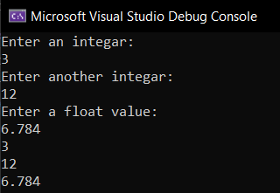

## Task 2: Arithmetic Operations

Write **simple calculator** program takes an arithmetic operator +, -, *, / and two operands from the user. Then, it performs the calculation on the two operands depending upon the operator entered by the user.

Code:

#include <iOStream>

using namespace std;

int main() {

float a, b,result;

char choice;

cout << "Enter a number: " << endl;

cin >> a;

cout << "Enter another number: " << endl;

cin >> b;

cout << "Press + to perform Addition" << endl;

cout << "Press - to perform Subtraction" << endl;

cout << "Press * to perform Multiplication" << endl;

cout << "Press / to perform Division" << endl;

cin >> choice;

if (choice == '+') {

result = a + b;

cout << result;

}

else if (choice == '-') {

result = a - b;

cout << result;

}

else if (choice == '*') {

result = a * b;

cout << result;

}

else if (choice == '/') {

result = a / b;

cout << result;

}

else {

cout << “Invalid choice!”;

}

return 0;

}

Output:

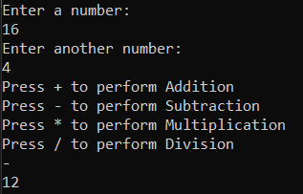

## Task 3 : Percentage

Write a C++ program that prompt input roll number, student name and marks of three subjects

1. Computer Programming = CP
2. Introduction to communication Technologies = ICT
3. Data Science = DS

Calculate total marks, percentage of student.

Marks percentage = marks obtained / total * 100

Code:

#include <iOStream>

#include <string>

using namespace std;

int main() {

string std_name;

int std_rol, marksOfCP, marksOfICT, marksOfDS;

cout << "Enter your name: " << endl;

cin >> std_name;

cout << "Enter your rol no: " << endl;

cin >> std_rol;

cout << "Enter marks of Computer Programming(CP): " << endl;

cin >> marksOfCP;

cout << "Enter marks of ICT: " << endl;

cin >> marksOfICT;

cout << "Enter marks of Data Science: " << endl;

cin >> marksOfDS;

float obtainedMarks = marksOfCP + marksOfICT + marksOfDS;

float percentage = (obtainedMarks / 300) * 100;

cout << "Total Marks = " << obtainedMarks << endl

<< "Percentage = " << percentage << "%";

return 0;

}

Output:

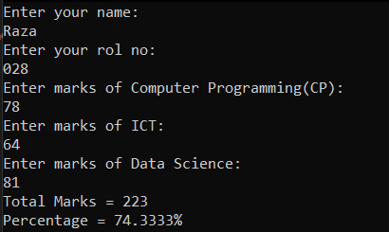

## Task 4 : Calculating Value of X

Write a program to solve the following equation. Take value of a and b from user.

X = (a + b)2

Code:

#include <iOStream>

using namespace std;

int main() {

float a,b;

cout << "Enter a: " << endl;

cin >> a;

cout << "Enter b: " << endl;

cin >> b;

float x = (a + b) * (a + b);

cout << "X = " << x;

return 0;

}

Output:

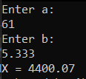

## Task 5 : Word Game

Write a program that plays a word game with the user. The program should ask the user to enter the following also display user age in days from current date.

User’s name

Year of birth (eg. 1990)

Name of university

A favorite hobby

A pet’s name

Write a program that will produce an outcome as below:

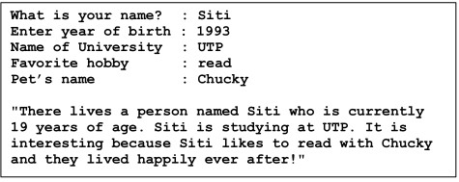

Code:

#include <iOStream>

#include <string>

using namespace std;

int main() {

int yearOfBirth;

string username, uni_name, hobby, pet_name;

cout << "What is your name? : ";

cin >> username;

cout << "Enter year of birth : ";

cin >> yearOfBirth;

cout << "Name of University : ";

cin >> uni_name;

cout << "Favourite hobby : ";

cin >> hobby;

cout << "Pet's name : ";

cin >> pet_name;

int age = 2023 - yearOfBirth;

int ageInDays = (2022 - yearOfBirth) * 60 + 11;

cout << "There lives a person named " << username << " who is currently " << age << " years and " << ageInDays << " days old. " << username << " is studying at " << uni_name << ". " << username << " likes " << hobby << " and also have a pet named " << pet_name << ". They often play together and live happily!";

return 0;

}

Output:

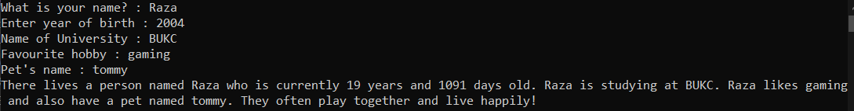

## Task 6

## Hypotenuse refers to the right angle in a triangle (as shown in the side opposite right-angled the diagram below).

## 

Hypotenuse can be calculated using the following formula:



Area of this right-angled triangle can also be calculated using the following formula: a = ½ * x * y



Note that:

h=Hypotenuse

x= adjacent

y= opposite

Write a C++ program that prompt user to enter value of X and Y. You have to calculate the value of Hypotenuse (h) and Area(a).

Code:

#include <iOStream>

#include <cmath>

using namespace std;

int main() {

float x, y, h, a;

cout << "Enter x : ";

cin >> x;

cout << "Enter y : ";

cin >> y;

h = sqrt(pow(x, 2) + (y, 2));

a = 0.5 * x * y;

cout << "Hypotenuse = " << h <<endl;

cout << "Area of triangle = " << a;

return 0;

}

Output:

